Test Case: tc002_SPX_Dev5_Crear_Requisicion_Spot_Tipo_Cobro_Project
Step 1 - Enter username and password and click to button Enter: Credentials Entered
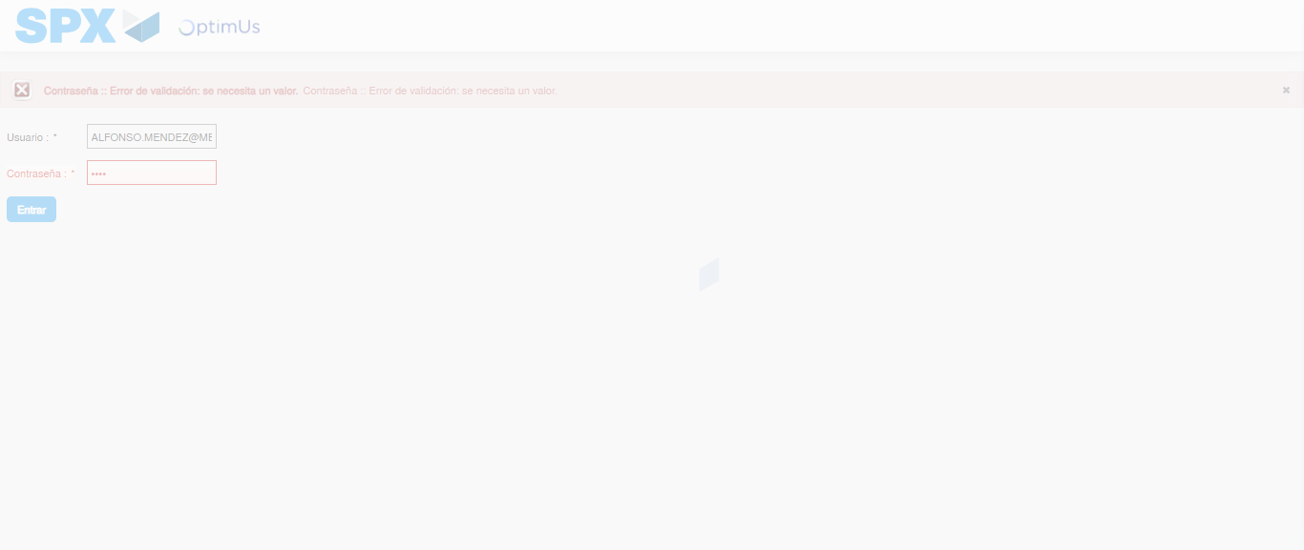Image file-name: QC_Testing-tc002_SPX_Dev5_Crear_Requisicion_Spot_Tipo_Cobro_Project-1783381754068

Step 2 - Select to UEN and Access to Spot Buy Requisitions : UEN Correctly selected and Correct access
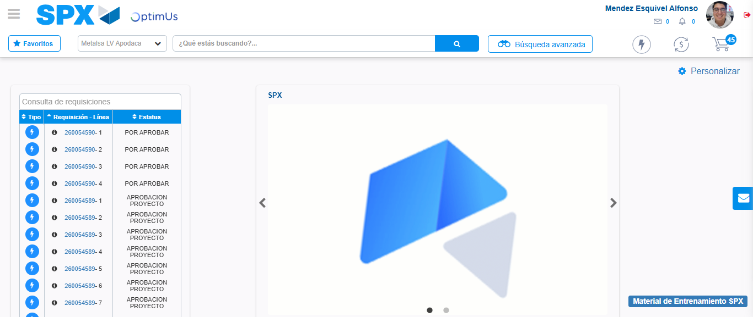Image file-name: QC_Testing-tc002_SPX_Dev5_Crear_Requisicion_Spot_Tipo_Cobro_Project-1783381815617

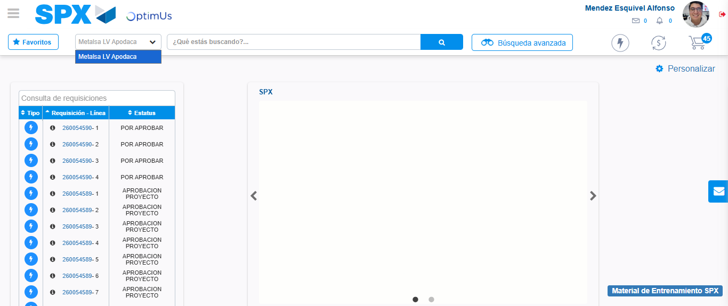Image file-name: QC_Testing-tc002_SPX_Dev5_Crear_Requisicion_Spot_Tipo_Cobro_Project-1783381818119

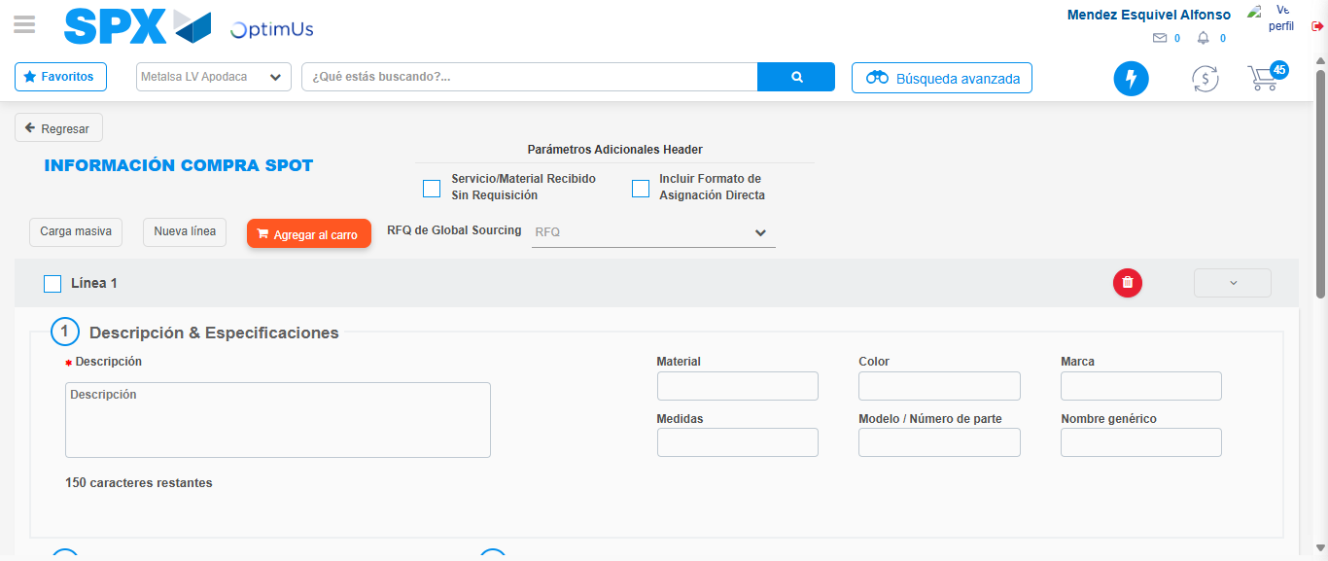Image file-name: QC_Testing-tc002_SPX_Dev5_Crear_Requisicion_Spot_Tipo_Cobro_Project-1783381822842

Step 3 - Data Capture Spot Buy Requisition: Data captured correctly
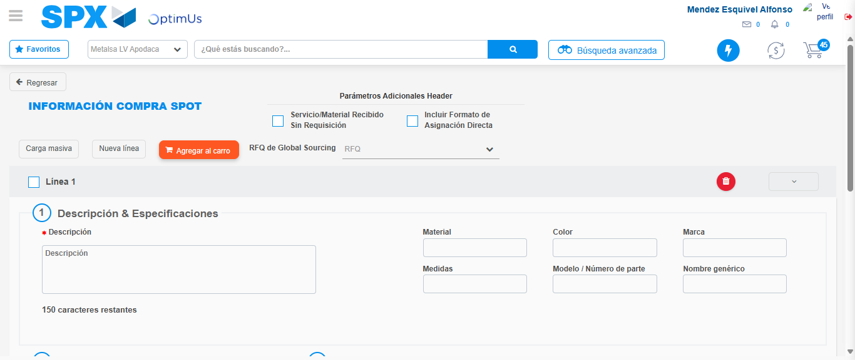Image file-name: QC_Testing-tc002_SPX_Dev5_Crear_Requisicion_Spot_Tipo_Cobro_Project-1783381823065

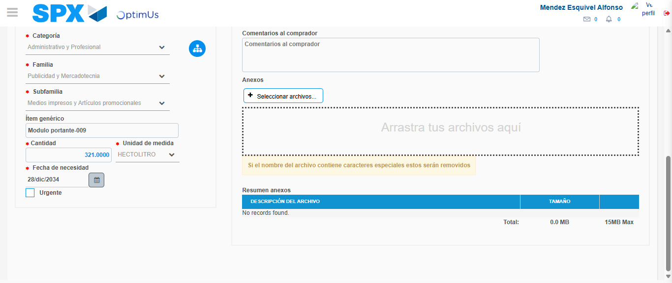Image file-name: QC_Testing-tc002_SPX_Dev5_Crear_Requisicion_Spot_Tipo_Cobro_Project-1783381832809

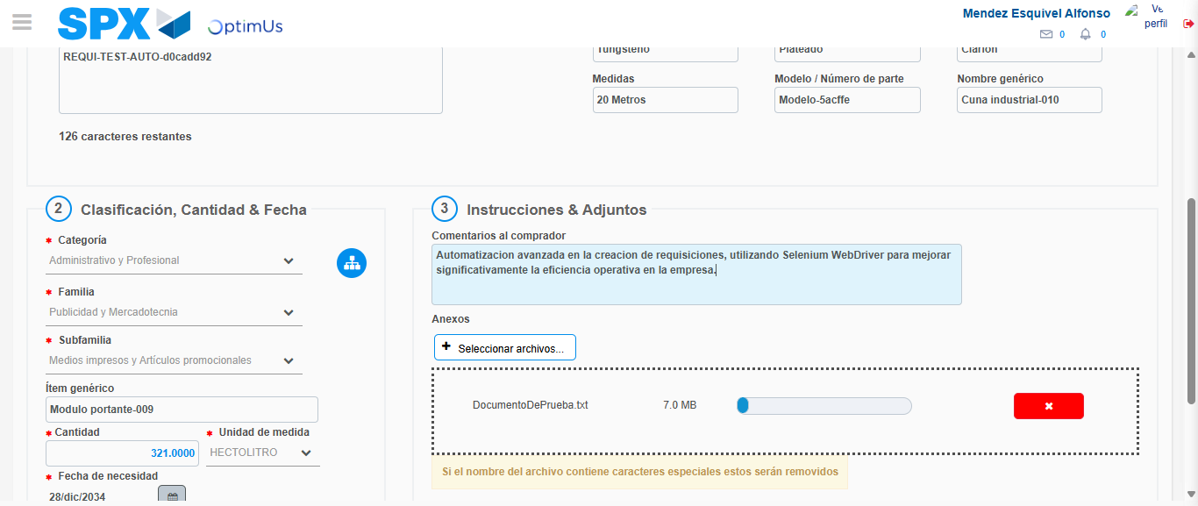Image file-name: QC_Testing-tc002_SPX_Dev5_Crear_Requisicion_Spot_Tipo_Cobro_Project-1783381833556

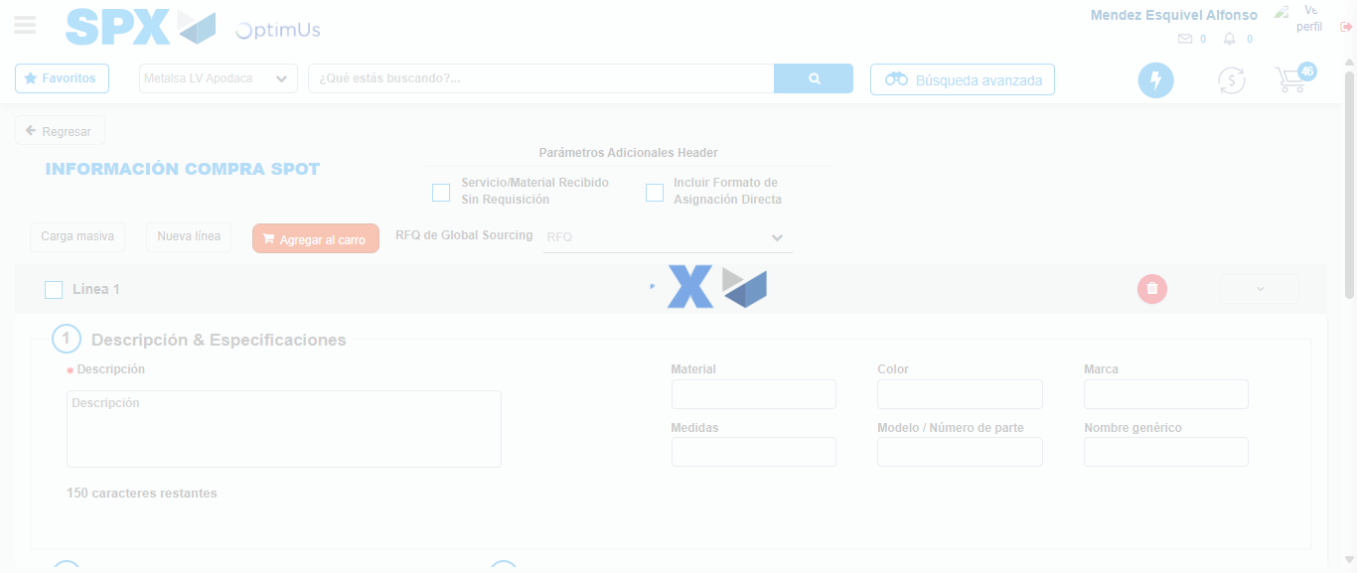Image file-name: QC_Testing-tc002_SPX_Dev5_Crear_Requisicion_Spot_Tipo_Cobro_Project-1783381840465

Step 7 - Return to Main Page SPX : Return to Main Page SPX
Image file-name: QC_Testing-tc002_SPX_Dev5_Crear_Requisicion_Spot_Tipo_Cobro_Project-1783381815617

Image file-name: QC_Testing-tc002_SPX_Dev5_Crear_Requisicion_Spot_Tipo_Cobro_Project-1783381818119

Image file-name: QC_Testing-tc002_SPX_Dev5_Crear_Requisicion_Spot_Tipo_Cobro_Project-1783381822842

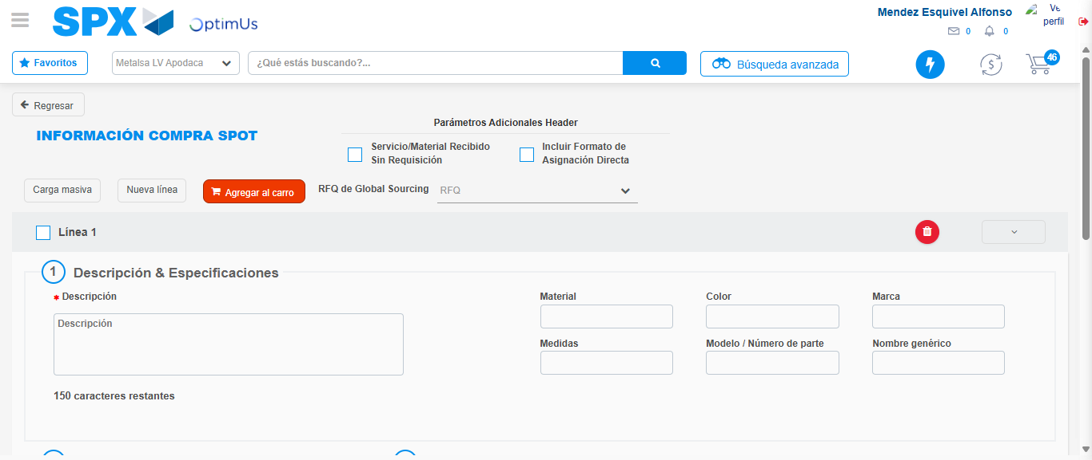Image file-name: QC_Testing-tc002_SPX_Dev5_Crear_Requisicion_Spot_Tipo_Cobro_Project-1783381842691

Image file-name: QC_Testing-tc002_SPX_Dev5_Crear_Requisicion_Spot_Tipo_Cobro_Project-1783381842905

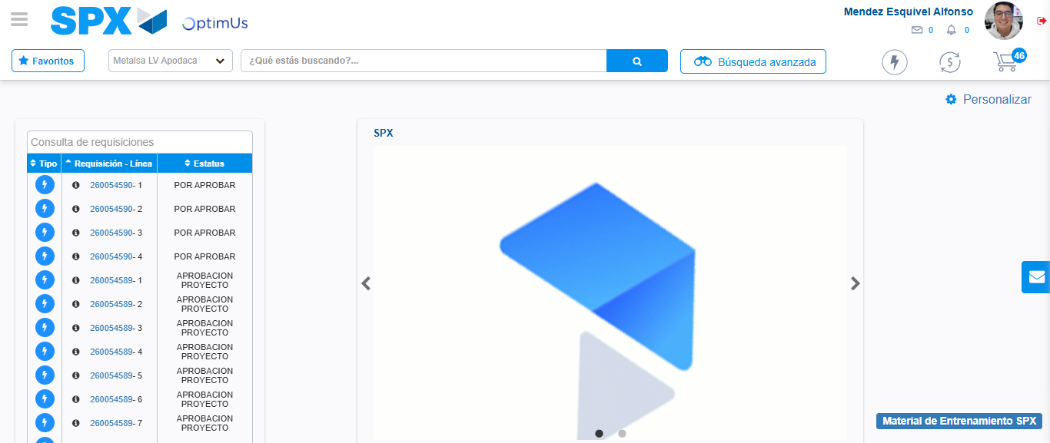Image file-name: QC_Testing-tc002_SPX_Dev5_Crear_Requisicion_Spot_Tipo_Cobro_Project-1783381863947

Step 8 - Log Out : Log Out SPX
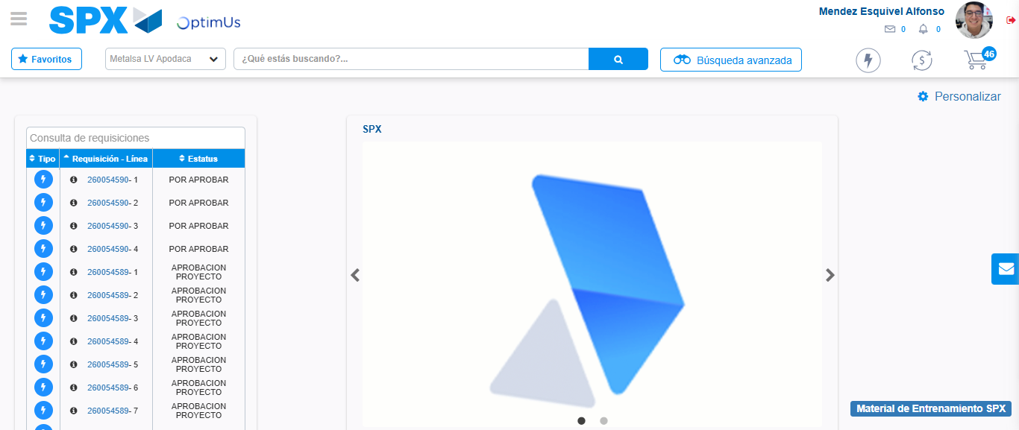Image file-name: QC_Testing-tc002_SPX_Dev5_Crear_Requisicion_Spot_Tipo_Cobro_Project-1783381864142

